GEOGRAPHY REPORT-
FLOODING
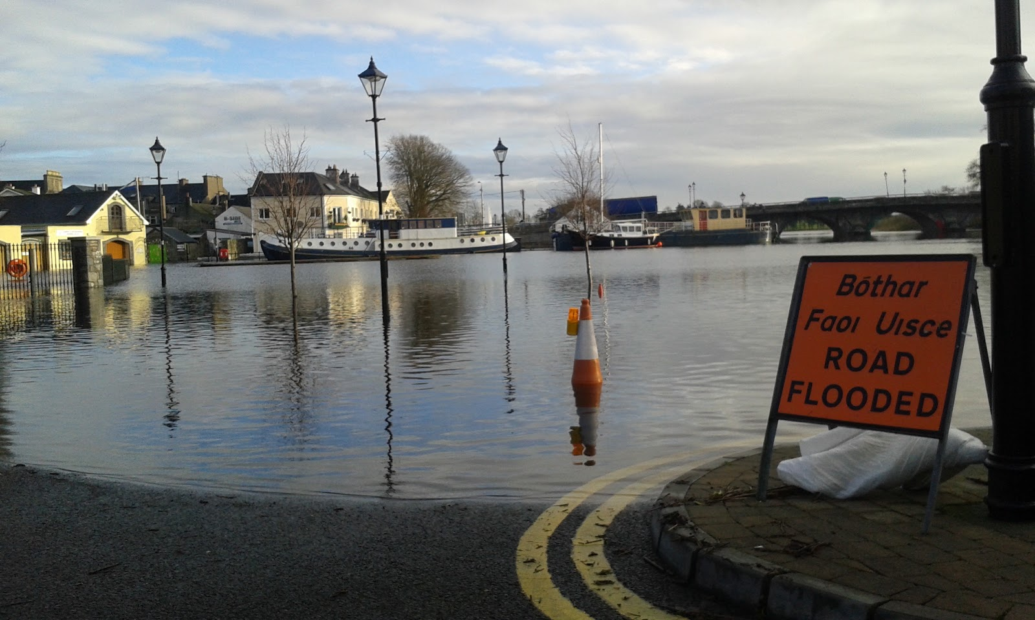
Introduction
There has been many floods throughout Ireland and the UK over the last couple of months, leading to the destruction of roads and in many cases, people’s homes. The rains in December were the heaviest for 52 years in many places. This report is based on the reasons for the weather conditions causing these floods and the impact the floods have had on the Shannon river region.
What is the cause of these floods?
Atlantic frontal systems, travel northeast over Ireland, bringing cloud and rain. The Atlantic is the cause of most of Ireland’s heavy rainfall.
“Flooding occurs most commonly from heavy rainfall when natural watercourses do not have the capacity to convey excess water.”
A combination of heavy rain, storms and coastal surges have been the cause of recent flooding. Torrential rainfall and strong winds brought recently by storm Frank have caused many floods in Ireland. Many rivers across Ireland have yet to peak, meaning further flooding is possible. Cork has been worst affected by the storm, where almost 3 inches of rain has fallen.

Kilkenny flooding- Storm Frank
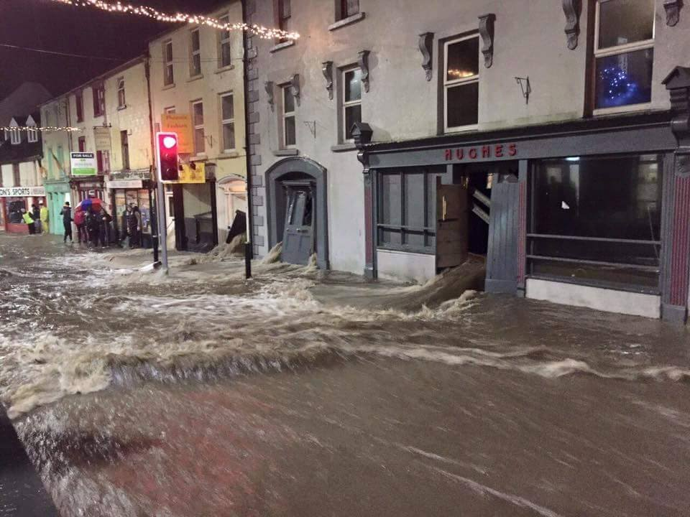

The Shannon River
Following a 7 cm water level increase, the Shannon in Athlone is now 10 cm above its previous peak recorded after storm Desmond. The corbally area of Limerick city has been severely affected by the flood waters as the nearby canal rose to an unanticipated high level due to a large quantity of water in the Shannon. Water levels on the river Shannon are beginning to decline. But about 100 members of the Defence Forces are still stationed around Clonlara, Dungarvan, Shannonbridge and Athlone, where they are contributing to pumping operations and providing transport.

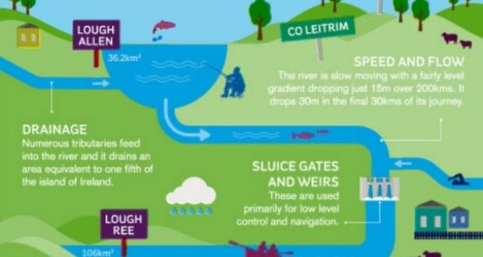

Impact-
Homes:
More than 260 homes around the country have been flooded so far. Another 230 are under threat while 130 houses have been marooned according to the National Coordination Group which met again this morning. Speaking after the meeting, the OPW said the river Shannon at Athlone had risen 5cm in 48 hours and is now 1cm above 2009 levels
Homes have been evacuated with the threat of further flooding having increased because of renewed persistent rainfall and scattered heavy showers
The band of wet weather has prompted Met Éireann to issue another warning for Cork and Kerry with up to 40mm of rain forecast to fall there throughout the day and tonight.
The flooding has had a very large impact and RTE speaker, Barry Keane, said that the amount of information and documentation people need to provide, means that they do not get access to funding until a number of months after their homes have been flooded.
Farming:
Farmers have said another 10,000 acres of land have been covered by water over the weekend. The farmers want the Department of Agriculture to defer inspections in flooded areas and go ahead with EU farm payments before the end of the week.
Co. Galway IFA Chairman Pat Murphy said that large acreages of land will be flooded throughout the Shannon region over the coming days.
Farm Family homes to be eligible under the humanitarian aid scheme. Minister for Agriculture and Defence, Simon Coveney will bring proposals to Cabinet for a broader scheme for farmers.
Industry:
So far it is estimated that 100 businesses have been affected by the flooding but this will probably rise.
Mr. Coveney also said that the Government may have to look at the size of the €5m fund for businesses at a later stage.
Government’s initial response to the flooding (2015):
The Government announced that businesses affected by the flooding will be able to get forms to apply for funding for compensation in the coming days on the Red Cross website.
The Minister for Defence Simon Coveney announced the details of a scheme to provide emergency humanitarian support to small businesses that have been unable to secure flood insurance and have been affected by Storm Desmond.
Simon Harris, said the cost of the clean-up after recent flooding will be more than €8 million. Out of the €8 million, €6m has already been drawn down by local authorities and the Minister for the Environment is expected to allocate more funding.
Government’s response to the flooding:
The Government on the 5th January, 2016 made a series of decisions designed to reduce the difficulties of those subjected to flooding in their homes and businesses.
These decisions included funding for a hardship recognition scheme for farmers, a fodder replacement scheme, and a clean-up fund increased by a further 10 million euro in addition to the 8 million already.
Other decisions include the establishment of a River Shannon co-ordination, Red Cross compensation to be extended to apply to sporting facilities, OPW to over-see two different home protection schemes, funding supplied in due course to Department of Transport etc.
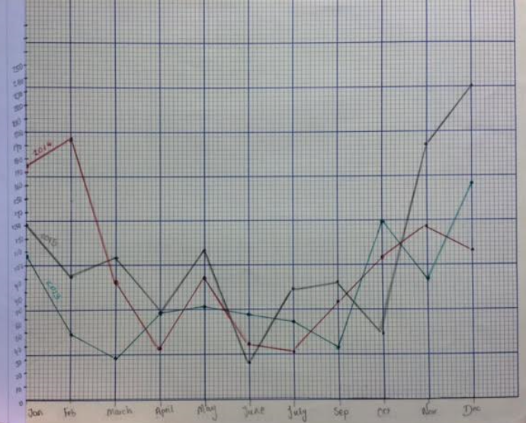
Using the information given in the graph, towards the beginning of 2014, we know that Ireland experienced heavy precipitation. June 2015 was the driest month in the last three years and in December that year, we experienced the largest amount of rainfall in three years. The average amount of rainfall that fell in December 2015 was much higher than all the other month averages for the last three years and is the reason for the many floods across Ireland.

