Introduction
Name: Norway
Global Position: The country of Norway is in the continent of Europe and the latitude and longitude for the country are 59°55'N and 10°45'E. Some neighbouring countries of Norway include Finland, Sweden, the UK and Russia.
Flag:
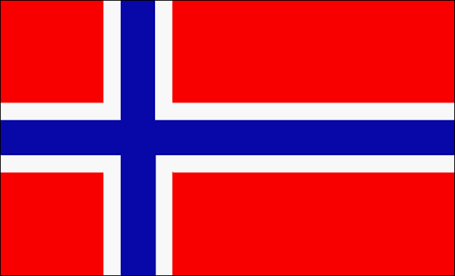

The name Norway comes from the Old Norse word meaning “northern way” or “way leading to the north”, which the Geat’s and the Danes named the coastline of western Norway.
History of Norway
The history of Norway has been influenced largely by the terrain and the climate of the region. About 10,000 BC, following the end of the ice sheets, the earliest inhabitants migrated north into the territory which is now Norway. They travelled northwards along the coastal areas, warmed by the Gulf Stream, where life was more bearable.
During World War II, Norway was under German occupation. Britain was one of Norway’s allies and King Haakon and his family lived in exile in the UK until the war was over. Norway is a peace-loving nation and is a member of the UN and NATO. Norway’s belief in negotiation as a way of settling conflict makes them the ideal country to award the Nobel Peace Prize each year.
In the late 1960s, enormous fields of oil and gas were discovered off the Norwegian coast. This has had a huge effect on the country’s economy and for the last eight years, Norway has been voted the best country in the world to live in by the UN.

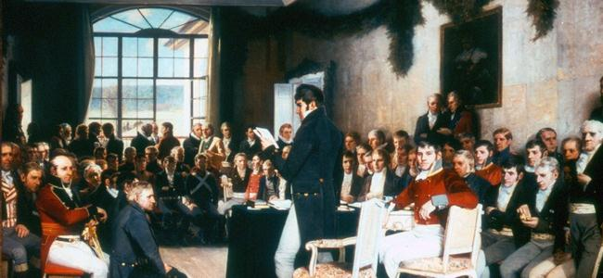

Geography of Norway
Climate-
The southern and western parts of Norway are exposed to Atlantic storms and they experience more precipitation. They have milder winters than the eastern and far northern parts. Areas to the east of the coastal mountains have less rain and snow than the west. The lowlands around Oslo have the warmest and sunniest summers but also cold weather and snow in the winter.
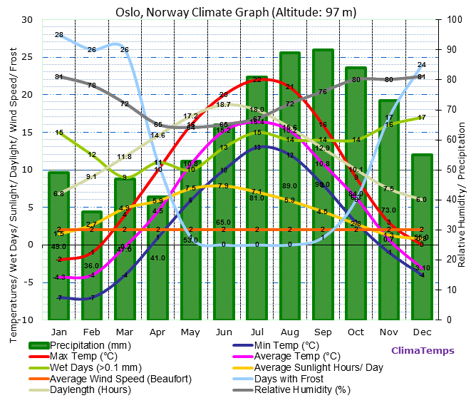

The coastal climate of Norway is very mild compared to areas on similar latitude elsewhere in the world – with the Gulf Stream passing directly offshore the northern areas of the Atlantic coast. The Scandinavian Mountains locks in continental winds from reaching the coastline, causing very cool summers throughout Atlantic Norway. Oslo has more of a continental climate similar to the Sweden. The mountain ranges have subarctic and tundra climates. There is also very high rainfall at areas exposed to the Atlantic, such as Bergen.
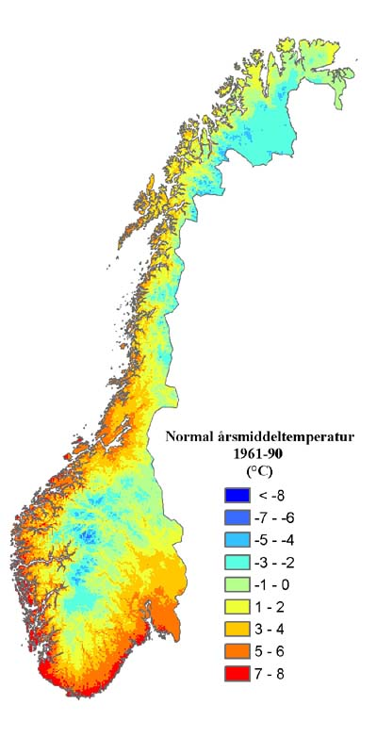
See the average temperatures in Norway. The north and the east show colder temperatures than the west and the south. The south coast displays the warmest average temperatures.

Environment-
Stunning scenery and landscape is found throughout Norway. The west coast of southern Norway and the coast of northern Norway present some of the most impressive coastal sceneries in the world. National Geographic has listed the Norwegian fjords as the world's top tourist attraction.

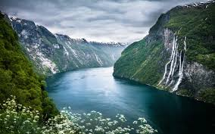

Norwegian Culture
Religion-
Until 2012 parliamentary officials were required to be members of the Lutheran Church and at least half of all ministers had to be a member of the Christian State Church. As the Church of Norway is the state church, its clergy are state employees, and the central and regional church administrations are part of the state administration. The members of the Royal family are required to be members of the Lutheran church.
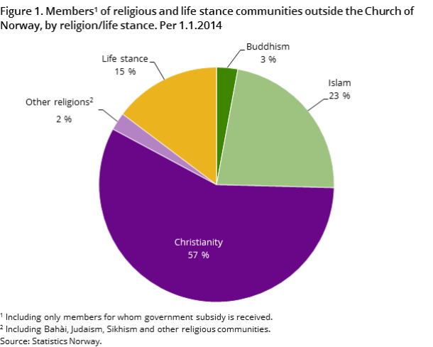

Human Rights-
Norway has been a progressive country, which has adopted many policies to support women's rights, minority rights, and LGBT rights. In 1884, 171 of the leading figures, including five Prime Ministers for the Liberal Party and the Conservative Party, co-founded the Norwegian Association for Women's Rights. They successfully campaigned for women's right to education, the right to work and other gender equality policies. From the 1970s, a public body to promote gender equality was established, which evolved into the Gender Equality and Anti-Discrimination Ombud. Civil society organizations also continue to play an important role.
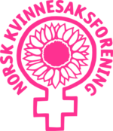

Music & Art-
The classical music of the composers Edvard Grieg, Rikard Nordraak and Johan Svendsen is internationally known as is the modern music of Arne Nordheim. Norwegian black metal has been an influence in world music since the late 20th century.
For an extended period, the Norwegian art scene was dominated by artwork from Germany and Holland as well as by the influence of Copenhagen. It was in the 19th century that a truly Norwegian era began, first with portraits, later with even more impressive landscapes. Johan Christian Dahl from the Dresden school, eventually returned to paint the landscapes of western Norway, defining Norwegian painting for the first time.

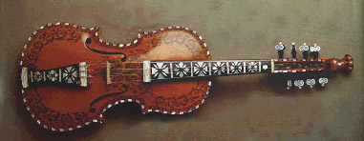

Languages of Norway
Official languages | Norwegian (Bokmål) and Nynorsk, Sami and Kven
Minority languages | Romani language
Main foreign languages | English (>80%)  German  French

Economy
Resources-
Norway is a developed mixed economy. Shipping has long been a support of Norway’s export sector, but much of Norway's economic growth has been fueled by an abundance of natural resources, hydroelectric power, and fisheries.
Norway's main natural resources such as natural gas, oil, copper, lead and timber have sustained a stable and resilient economy, but it is the management of this resource wealth that differentiates Norway as a nation. Norway is a large exporter of seafood, and the world's third largest exporter of petroleum.
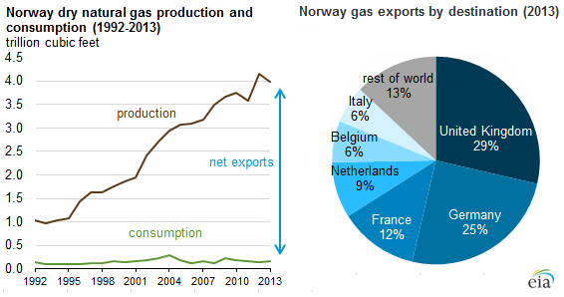
Manufacturing-
Agriculture and traditional heavy manufacturing have suffered decline compared to services and oil-related industries. The country has a very high standard of living compared to other European countries, and a strong welfare system. Norway's modern manufacturing and welfare system rely on a financial reserve produced by exploitation of natural resources, particularly North Sea Oil.
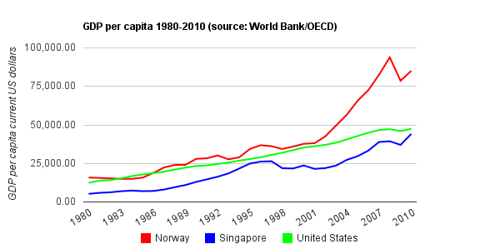
A graph of Norway’s growing economy, it shows a rapid rise from 2002.
Tourism-
The main attractions of Norway are it’s different landscapes. It is famous for its fjords along the coastline and its mountains, ski resorts, lakes and woods. The main tourist cities in Norway are Oslo, Bergen, Stavanger, Trondheim and Tromsø. A lot of the nature of Norway is still undisturbed, and therefore it attracts numerous hikers and skiers. In the cities, historic and cultural buildings and areas such as Bryggen in Bergen and the Vigeland Sculpture Park in Oslo also attract many visitors.

Financial Services-
‎DNB is Norway’s largest financial services group.


Transport-
Transport in Norway is mainly influenced by it's low population density, narrow shape and long coastline. Norway has old water transport traditions, but road, train and air transport have increased in importance. Due to the low population density, transport is less built out in rural areas of Norway, however public transport in, and around cities is well developed.

Demographics
Norway's population was 5,096,300 people in October 2013. Since the late 20th century, Norway has attracted numerous immigrants from southern and central Europe, the Mideast, Africa and Asia. All of these groups speak many different languages and come from different cultures and religions. In 2012, an official study showed that 86% of the total population have at least one parent who was born in Norway.
Emigration-
Particularly in the 19th century, when economic conditions were difficult in Norway, tens of thousands of people migrated to the United States and Canada, where they could work and buy land in frontier areas. Many went to the Midwest and Pacific Northwest. In 2006, according to the U.S. Census Bureau, almost 4.7 million persons were found to be Norwegian Americans, which was larger than the population of ethnic Norwegians in Norway itself. In the 2011 Canadian census, 452,705 Canadian citizens identified as having Norwegian ancestry.



